Changes in citres website

CITRES font: Neuropol (everywhere CITRES should be in the same style)
Home: add nondestructive testing image in the home page slides
Advisory committee: Er. Chandra sekhar Rao VT
M.E., Civil engineering with structural specialization.
Our services: change pics in every topic (add related photos to the topic)
Arrange services in the alphabetical order everywhere in the website.
Testimonials: remove this
About us: change picture bcoz that picture is wrong
Our team: rename as “our business partners”
1)Dr. Venkateswara rao MV
2)Dr.M.V. Seshagiri Rao
Name : DR. M. V. Seshagiri Rao
Experience : 37 years of Research, Teaching,
Construction, Consultancy
Present Designation : Professor of Civil Engg & Dean
Organization : CVR College of Engineering
Hyderabad
Qualifications : B. Tech ,M. Tech (STRUCTURAL ENGG) ,M. S (SOFTWARE SYSTEMS),Ph. D (CIVIL ENGG.)
Posts Held :Asst. Executive Engineer in A.P. Engineering Research Labs. (1978 to 1985), Head of Civil Engg. Dept. (2002-2005), Vice Principal, JNTU College of Engg., Hyderabad (2005 -2006), Director, BICS, JNTU (Cobined University) (2006 -2007), CHIEF ENGINEER, JNTU (Cobined University) (2006- 2007), Head of Civil Engg. Dept. (2008-2010), Chairperson, Board of studies, JNTUH& JNTUHCEH (2008-2010), Coordinator, NBA Nodal Center, JNTUH (2013- May 2016), Professor& Dean (Planing& Coordination) (CVR College of Engineering, Hyderabad)2016-till date.
Awards/ medals received:1. Outstanding Concrete technologist 2006 Award by Indian Concrete Institute (AP, Hyderabad),2.Bet technical paper award by The Institution of Engineers (India), Hyderabad for the paper MICROBIAL CONCRETE-A SUSTAINABLE SOLUTION FOR CONCRETE CRACK REPAIR AND REHABILITATION –October 2015
Research Publications : 191(includes research papers in various national and international
conferences and journals)
Research Guidance : * Guided 21 Ph. D Thesis
* 6 Ph. D Projects are in Progress
* Guided 131+ M. Tech Projects
Research Projects : 1. High Performance Rice husk ash cement concrete
2. High volume fly ash concrete with fly ash as an additional
material
3. Several projects sponsored by private organizations
4. Principal; Investigator for the Center of Excellence in Disaster
Management under TEQIP-II (ongoing)
Books Authored : 1. Text book on “ Engineering Mechanics” published by
Universities Press-2005.
2. Concrete Technology for B. Tech (Correspondence cum Contact Programme) For J.N.T. University.
Industrial Experience: 1. As a member of Industrial Consultancy Services of JNTU offered
consultancy to various Government and Non- Government
organizations in particular on Quality control, Concrete Mix
Designs and Non Destructive Testing of Civil Engineering Works
with in Andhra Pradesh and Outside of AP.
2. Involved in the third party quality control checks for various
government and non government works
3. Involved in the checking of designs for important structures of
various government and non-government works.
Memberships in professional bodies : Life Member in FIE, MISTE, MICI, M.I.W.R.S

3)Er.L.M.Rao
4) Er.Murty GVS

Advisory committee : Er.Chandra sekhar rao VT
M.E.,Civil engineering with structural specilisation.
Services : rename “architects and engineers”to architectural engineering consultancy.
Downloads : change background picture
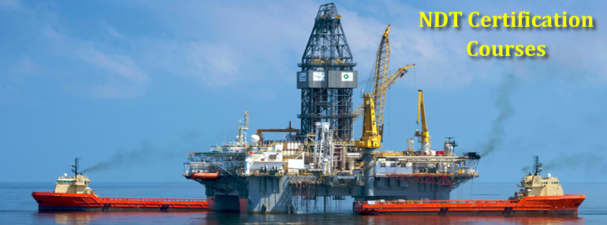
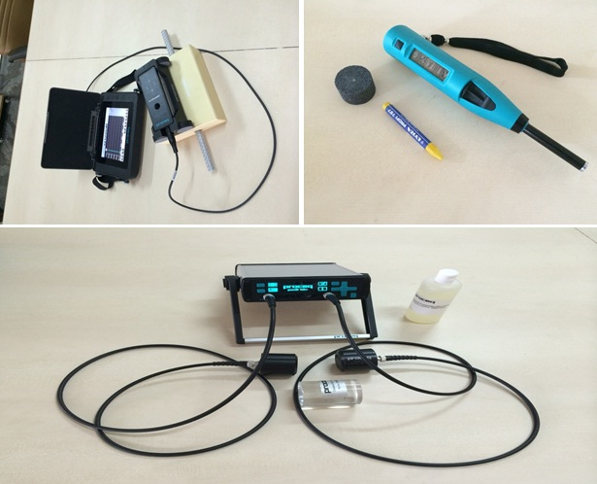

Our clients: MYLON,IOCL,COC,HPCL,BPCL,ESSAR,APHB,SAAP
Contact us: Banglore- banglore@citres.in
Kakinada-kakinada@citres.in
Emails: info@citres.in
venkat@citres.in
murty@citres.in
saikishore@citres.in
accounts@citres.in
NDT@citres.in
banglore@citres.in
kakinada@citres.in

