Approved 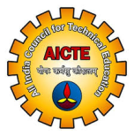 | SCIENT Educational Society  Nagarjuna Sagar Highway, Ibrahimpatnam  Hyderabad 501 506, Telangana State  http:// www.scient.ac.in ; www.scientpharmacy.ac.in  ISO: 9000-2001 Institutions, Established: 2001 | Affiliated 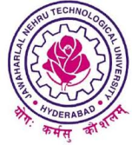

Code: SNTI | SCIENT Institute of Technology  SCIENT Institute of Pharmacy | 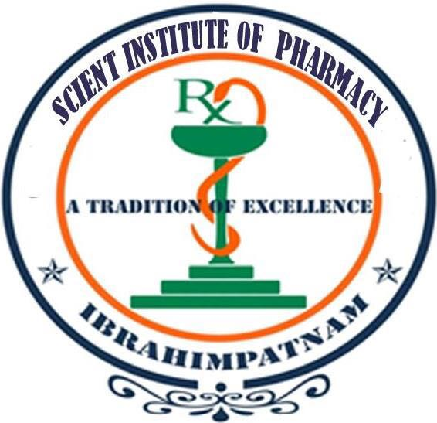Code: SCTP

The nomenclature SCIENT originates from Latin sciēns (“knowing”), from sciō (“know”) synonymous to skilful which the institute strongly believes to imbibe among its pupil. Survival of the fittest is the say, of the contemporary world of Technology and only the skilful can survive the chaotic world job scenario.

Vision:
To provide QUALITY EDUCATION in Engineering and Technology through efficient teaching and giving exposure to good engineering practices with a familiarity of National and International codes of practice and by developing a strong bilateral relationship with industry and leading professional institutions within country and aboard.

BACKGROUND OF SCIENT INSTITUTE OF TECHNOLOGY:
SCIENT stood first among five competes in the year 2001 to achieve the distinction from the state government to establish an Institute of Technology in the entire Ibrahimpatnam zone.

Located on the Nagarjuna Sagar road spread over 32 acres of land in a serene surrounding offering quality education equipped with modern laboratories. Affiliated to prestigious Jawaharlal Nehru Technological University, Hyderabad and duly approved by All India Council for Technical Education, New Delhi.

The Motto:
“Yoga: Karmasu Kaushalam”
Literally means: Practice Fate Perfection.
Diligent practice of a work results in a perfect outcome.

Quality Policy:
To enrich and enhance the students’ potential by providing a satisfactory, productive and accountable learning environment that sustains instructional excellence while adapting to the changing industrial and societal needs through continual improvement complaint with the requirements of Quality Management Systems.

Infrastructure:
The Institute has more than 600 branded systems of DELL, Lenovo&, HCL Computers with latest processors with 32 Mbps broadband Internet and Wi-Fi facility operating with required software updates on Local Area Network. Laboratories with modern facilities and advanced equipment to carry research works are available to students, which are over and above the required curricular standards.
The institute also facilitates Computational Infrastructure Services to TCS-Ion a Tata Enterprise. Advanced English Language Communication Skills (A-ELCS) laboratory supports practical learning in terms where a learner can utilize it as a working English Language.

The Library has a vast collection of over 40,000 books and subscribes to quite a good number of Indian and Foreign Journals including IEEE publications. Students can browse these 288 journals. A large number of CD/DVDs are also available in an e-format in almost all the important subjects of Engineering, Computers and Management fields.

Academia for Technology Stream
Dr. Moinuddin K Syed, is a distinguished personality with a vast experience of over 25 years dedicated completely to teaching, research and development. Graduated from reputed Osmania University, Hyderabad in Electrical Engineering, earned Masters Central University, A.M.U, Aligarh and Doctorate of Philosophy (Ph.D.) from Jawaharlal Nehru Technological University, Hyderabad, India. An active professional, honored with Fellow of Institution of Engineers, India (FIE), a Life Member of Indian Society for Technical Education (ISTE), a Life Member of Bio-Medical Engineers Society of India (BMESI) and Member, Institute of Electrical & Electronics Engineers (IEEE-USA). He is renowned in the field of Electrical Engineering for his appearance delivering 20 Video lectures on AP SONET TV Broadcasts and Globarena-JNTU(H) Live Interactive Video Sessions on Electrical Measurements. An expert in Electrical Quality, Measurements, Distribution and Machine Analysis and diversified knowledge on Bio-Medical, Precision, Process Control Instrumentation and Lasers.

Dr. S Yadagiri, Professor, HoD (Mechanical) has done his B.E. (Mech.) from Osmania University and M.E. (Aero.) from IISc, Bangalore. He obtained his Ph.D. from NIT Warangal. He has got seven years of experience as Scientist in Vikram Sarabhai Space Centre, ISRO. He has over three decades of experience in academics, out of which he had been the Principal for 15 years to NBA accredited and autonomous engineering colleges. He is known to be an expert in academic management and is reputed for his disciplinary systems. He has guided two Ph.D. scholars. He has published 12 papers in various International and National Journals and 10 papers in ISRO. He is the recipient of Rastriya Samman Puraskar from Indian Economic Development and Research and Rastriya Nirman Ratan from Indian International Council for Industries and Trade. He is the Fellow of Institution of Engineers and member of ISTE.

Dr. G Prabhakar Rao, Professor, CSE is a doctorate with over 7 years of experience, having background in Image Enhancement Techniques for Data Hiding and Security in Computer Science Engineering. He worked with several prestigious intuitions before he joined SCIENT.

Dr. Devesh Sharma, Professor, ECE is a young doctorate and is an expert in Wireless Communications with rich experience in academics and industry. He has several International and National Technical Paper Publications to his credit.
Prof. Ravi Thapally, is a professional with rich industrial and academic experience spanning over 17 years an MBA, M.Phil, Ph.D. he specializes in Marketing, HR and MS. His research interests are in the area of CRM in Insurance Sector and presented number of papers in various National and International Conferences. He served CITI BANK Hyderabd, Matri Media Group an MNC Company, Vice principal and Professor with several reputed academic Institutions and is working with us for the past 6 years as HoD, MBA
Courses Offered in Technology:

Undergraduate Course (B. Tech.)
Name of the Courses | Duration | Intake
Computer Science And Engineering | 4 Yrs. | 120
Electronics And Communication Engineering | 4 Yrs. | 120
Electrical And Electronics Engineering | 4 Yrs. | 60
Mechanical Engineering | 4 Yrs. | 60

Postgraduate Courses (M. Tech)
Name of the Courses | Duration | Intake
VLSI & Embedded Systems | 2 Yrs. | 36
Computer Science And Engineering | 2 Yrs. | 42
Power Electronics | 2 Yrs. | 24
Machine Design | 2 Yrs. | 24

BACKGROUND OF SCIENT INSTITUTE OF PHARMACY:
SCIENT-IP stands distinguished among outstanding pharmacy colleges affiliated to the JNT University (Hyderabad). Established in the year 2007 it has show tremendous growth and caters to varied courses with Ultra Hi-Quality Modern laboratories in hand shake with International branded Pharmaceutical Industry. The institute is Affiliated to prestigious Jawaharlal Nehru Technological University, Hyderabad and duly approved by All India Council for Technical Education, New Delhi and Pharmacy Council of India, New Delhi.

Academia for Pharmacy Stream

Dr. Neeraj Kaul, Principal is a Gold Medalist for his Ph.D. from Bharati Vidyapeeth University, Pune specialized in Pharmaceutical Analytical Chemistry with over 14 years experience in academics and pharmaceutical industry. He is an International Reviewer for Journal of Separation Science (JSS), Inter-Wiley Science, USA. To his credit he has 22 International and 4 National Paper Publications. He has Industrial Protocols with Centaur Pharma and Dr. Reddy’s Labs. Hyderabad.

Prof. U Mohan Kumar, Professor & Vice-Principal has over 10 experience, Ph. D. from JNT University, Anantapur and M. Pharm. from Dr. MGR Medical University, Chennai and is specialist in Pharmaceutics renowned among the students for his teaching and counseling skills. He has to his credit publications in 5 International, 12 National Journals, guided industry standard student projects in B. Pharm. and M. Pharm.

Other Distinuished Academics of Pharmacy are Dr. M Rizwana Basha, HoD, Pharmaceutics and Dr. A Manikanta, HoD, Pharmaceutical Management & Regulatory Affairs.

Courses Offered in Pharmacy: (EAMCET Code: SCTP )
Name of the Courses | Duration | Intake
B. Pharmacy | 4 Yrs. | 100
M. Pharmacy.( Pharmaceutics) | 2 Yrs. | 96
M. Pharmacy. (Pharmaceutical Analysis & Quality Assurance) | 2 Yrs. | 18
M. Pharmacy. (Pharmaceutical Management & Regulatory Affairs) | 2 Yrs. | 48

Training & Placement:
The Training and Placement cell of the institute provides ample opportunities to the students to develop their personality by conducting programs regularly on various soft skills. The Training and Placement Cell of the Institute is very dynamic and pro-active and in full coordination with faculty of English and soft skills experts and also by utilizing the Advanced English Lab facilities. Training and Placement Cell arranges career orientation programs on GRE, TOEFL GATE, CAT, MAT and IES etc. The students of this institute are placed in companies like Infosys, Satyam, Wipro, TCS, Verizon, HCL, DELL, IBM, I–Gate Global, Birla Soft, InfoTech, Sutherland Global Services, Aryans Info way etc.

Technical, Cultural, Sports, NSS and Extra Curricular Activities:
SCIENT conducts Samvigyan an annual event of the institute during the months of February & March. Students from various engineering colleges participate in competitive events like Technical Papers, Posters Presentation, Projects, Quiz etc. and prizes are awarded to the toppers.

Adequate canteen facilities are provided at the institute for the benefit of students and staff. A well established cafeteria, having around 2000 sq. feet area serves the above purpose with a qualitative food at reasonable and subsidized rates.

The college has National Service Scheme (NSS) attached with the university and is a regular participant in public service activities Playgrounds for different sports viz. Cricket, Badminton, Volleyball, Kho-Kho are available.

Transport:
The institute possesses its own fleet of buses meandering through various routes of the twin cities with nominal fees to extend the facility economically.

SCIENT Educational Society:
A group of eminent persons viz., educationists, technocrats, industrialists wanted deliver educational services to the society thereby starting an Institute of Technology. This noble thought resulted in formation of SCIENT Educational Society in Hyderabad and has established SCIENT Institute of Technology in 2001.

The prime objective was to serve the society at large by produce skilled manpower to serve the National Objectives. The members’ of this prestigious society are

- Sri. Gobind Ram Babbani President
- Sri. D Sunil Kumar Vice President
- Sri. KC Sheker Reddy Gen. Secretary
- Sri. Kishore K Babbani Treasurer
- Sri. A Harikishan Rao Jt. Secretary
- Smt. K Nagalakshmi Reddy Jt. Secretary

Highlights of the Institute:
- Established in 2001, Single College on spacious 32 Acres Campus.
- Ph. D. Faculty in all departments.
- Spacious Classrooms and AC Seminar Hall.
- E-Classrooms and Power Point presentation is a habitual feature.
- All Laboratories have high quality Modern Lab. Equipment.
- Excellent Training & Placement Facilities.
- Certification Programmes through the Curriculum.
- Large Computer laboratory with Hi-Speed Internet & Wi-Fi Connectivity.
- Huge Library with Book Bank Facility.
- Bus Facility from major parts of Twin Cities.
- Good Canteen Facility with nominal rates.
- Vast Playgrounds are available.

Visit once, get satisfied and click option on SNTI.

